Git Interview Questions and Answers
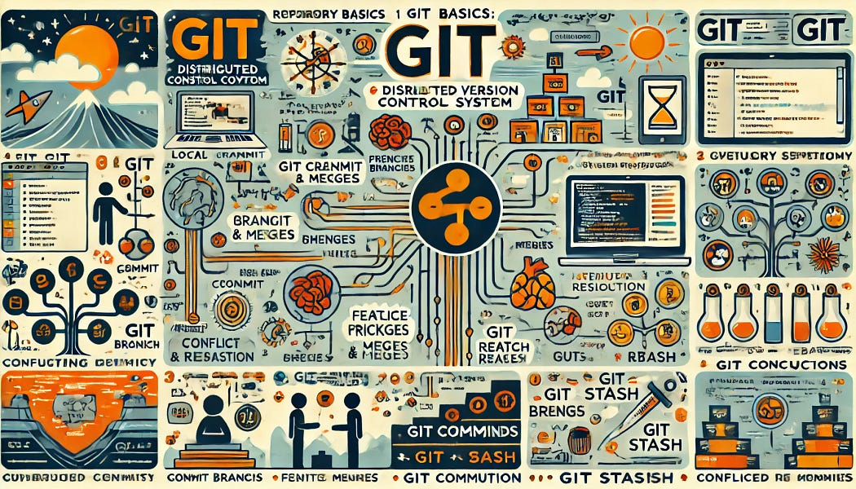

1. "What is the difference between git merge and git rebase?"
2. "Difference between merge and rebase?"
3. "Difference between git merge and rebase?"
4. "What is git stash and when do you use it?"
5. "What is git stash?"
6. "What is git cherry-pick?"
7. "What branching strategy do you follow in your project?"
8. "What branching strategy do you follow?"
9. "How do you resolve merge conflicts?"
10. "What to do in merge conflict?"
11. "What is merge conflict?"
12. "What is the difference between git pull and fetch?"
13. "Difference between git pull and fetch?"
14. What is the difference between Git and GitHub?
15. Difference between Git, GitHub, Bitbucket?
16. What is SCM?
17. What is the purpose of branches in Git?
18. What does git push do?
19. How do you clone or bring GitHub code to your local machine?
20. What is the difference between git fetch and git pull?
21. What is git stash and when do you use it?
22. What is git cherry-pick?
23. What is the difference between git merge and git rebase?
24. Difference between revert, rebase, and merge?
25. What branching strategy do you follow in your project?What is a merge conflict?
26. How do you resolve a merge conflict?
27. How do you manage code in GitHub?
28. What is GitHub Actions? Have you used it?
29. How do you configure webhooks to trigger Jenkins from Git?
1. What is Git?
Answer:
Git is a free and open-source distributed version control system (VCS) designed to handle everything from small to very large projects with speed and efficiency. It helps track changes in source code, enabling multiple developers to collaborate on the same project without conflicts. Git allows branching, merging, and maintaining different versions of code while ensuring data integrity.
2. Which programming language is Git written in?
Answer:
Git is written primarily in the C programming language, which ensures high performance and efficiency by minimizing the runtime overhead that higher-level languages introduce. This makes Git fast and lightweight, capable of handling large repositories with ease.
3. What is a repository in Git?
Answer:
A repository (repo) in Git is a storage location for a project’s files and its entire version history. It includes:
- The working directory (where actual files reside)
- A hidden .git directory (which contains commit history, branches, tags, and configuration settings)
- A staging area (for tracking changes before committing them)
Repositories can be local (on a developer’s machine) or remote (hosted on platforms like GitHub, GitLab, or Bitbucket).
4. What is a bare repository in Git?
Answer:
A bare repository is a Git repository that does not have a working directory. Instead, it contains only Git metadata and version control information. It is primarily used as a central repository for remote collaboration, where developers push and pull changes without directly modifying files.
Command to create a bare repository:
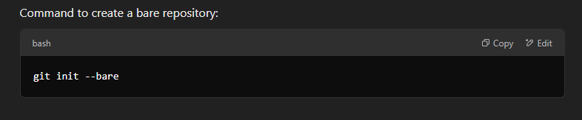
5. What is the purpose of git stash?
Answer:
git stash temporarily saves uncommitted changes in a stack-like storage without committing them. This is useful when a developer needs to switch branches or work on another task but doesn’t want to commit incomplete work.
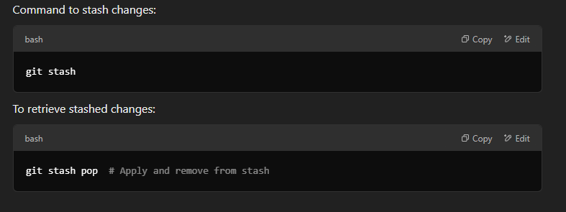

6. What does git stash drop do?
Answer:
The command git stash drop removes the most recent stash entry from the list of stashed changes.
To delete a specific stash entry:
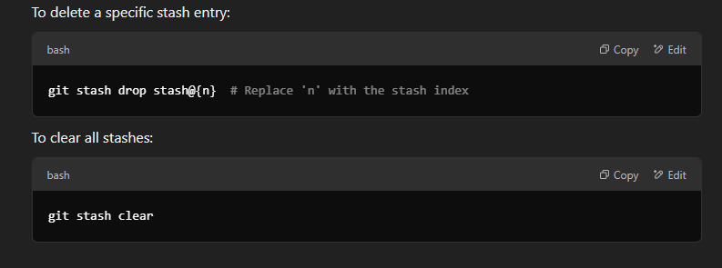
7. What are the advantages of using Git?
Answer:
- Distributed version control — Every developer has a full copy of the repository.
- Fast and efficient — Git is optimized for performance, handling large projects efficiently.
- Supports local and remote repositories — Developers can commit changes locally before pushing them remotely.
- Powerful branching and merging — Git allows seamless feature development and integration.
- Optimized for collaboration — Multiple developers can work simultaneously without overriding each other’s work.
- Strong security and data integrity — Uses SHA-1 hashing to ensure data safety.

8. What does the git push command do?
Answer:
git push uploads committed changes from a local repository to a remote repository, making them available to other collaborators.
Example:
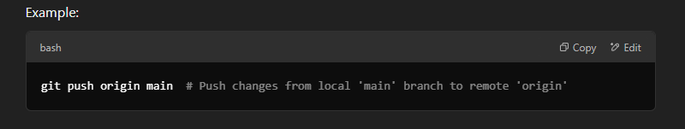
9. Why is branching important in Git?
Answer:
Branching allows developers to work on different features or bug fixes independently, without affecting the main codebase. It supports:
- Parallel development — Different teams can work on separate branches.
- Feature isolation — New features are developed in separate branches before merging into the main branch.
- Rollback capabilities — Developers can revert to previous versions if needed.
Example of creating a new branch:
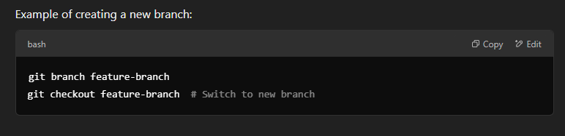
10. What is the purpose of git config?
Answer:
git config is used to configure user-specific Git settings such as name, email, and default behaviors.
Set global username and email:
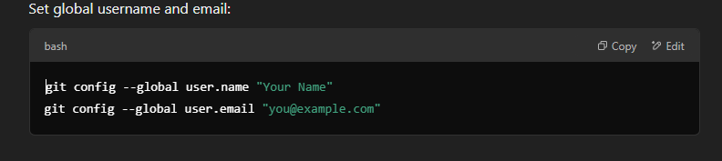

11. What is the staging area (Index) in Git?
Answer:
The staging area (Index) is an intermediate space where changes are reviewed and formatted before committing them. It allows developers to selectively commit changes.
Command to add changes to the staging area:
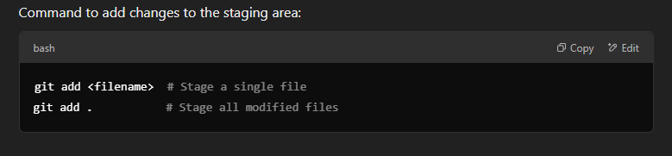
12. What is a conflict in Git?
Answer:
A Git conflict occurs when two branches modify the same section of a file, and Git cannot automatically merge the changes. Developers must manually resolve conflicts before merging.
13. What is the difference between git pull and git fetch?
Answer:
- git fetch downloads changes from a remote repository but does not merge them.
- git pull downloads changes and automatically merges them into the current branch.
Formula:
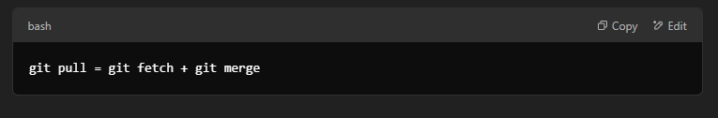
14. How do you resolve a conflict in Git?
Answer:
- Open the conflicting file and manually edit the conflicting sections.
- Use git add <file> to mark the file as resolved.
- Run git commit to finalize the merge.
15. What does git clone do?
Answer:
git clone creates a copy of a remote repository, including its full version history.
Example:
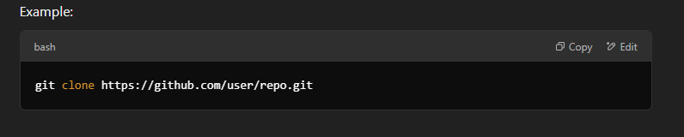
16. What does git pull origin <branch> do?
Answer:
This command fetches and merges changes from the remote repository (origin) into the current branch.
Example:
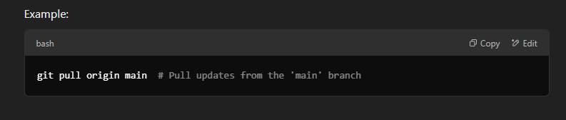
17. What does git commit do?
Answer:
git commit saves changes from the staging area to the local repository.
Example:
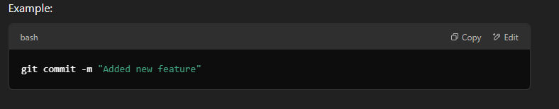

18. How is Git better than Subversion (SVN)?
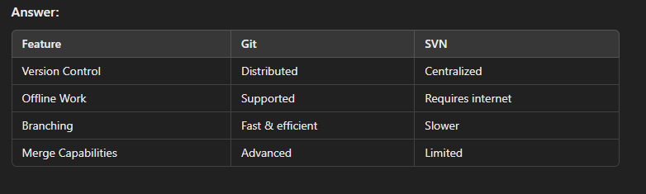
19. What is a commit message?
Answer:
A commit message is a short description of the changes in a commit. It helps track modifications and understand project history.
20. Why should new commits be created instead of amending existing commits?
Answer:
- Amending rewrites history, making collaboration difficult.
- New commits maintain clarity in version control.
21. What are Git hooks?
Answer:
Git hooks are scripts that execute before or after Git operations (e.g., commits, merges). They help automate tasks like code formatting and security checks.
22. What does a commit object contain?
Answer:
A commit object consists of:
- A snapshot of project files at that moment.
- References to parent commits.
- A unique SHA-1 hash identifier.
23. What branching strategies have you used?
Answer:
- Feature Branching — Separate branches for new features.
- Task Branching — Each task has its own branch.
- Release Branching — A stable branch for releases.

24. What is the difference between git merge and git rebase?
Answer:
Both git merge and git rebase integrate changes from one branch into another, but they work differently:
- git merge creates a new merge commit, preserving the history of both branches.
- git rebase moves or rebases commits from one branch onto another, creating a linear history.
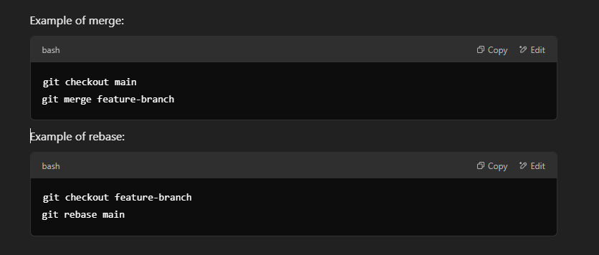
25. What is the git cherry-pick command?
Answer:
git cherry-pick allows selecting a specific commit from one branch and applying it to another.
Example:
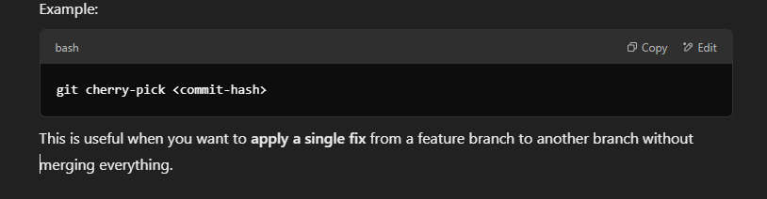
26. What is a detached HEAD in Git?
Answer:
A detached HEAD occurs when Git’s HEAD is pointing to a specific commit instead of a branch.
Example of switching to a specific commit:
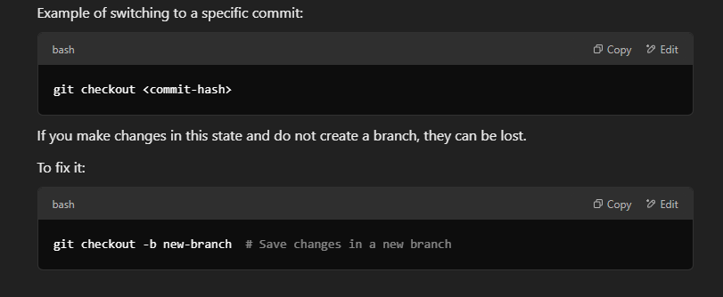
27. What is the difference between git reset and git revert?
Answer:
- git reset moves the branch pointer backward in history, effectively deleting commits.
- git revert creates a new commit that undoes a previous commit while keeping the history intact.
Example of reset:
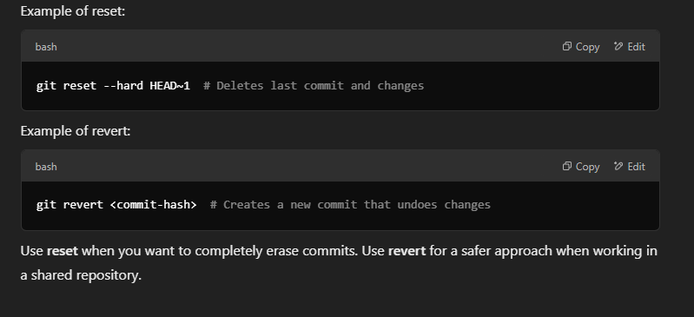

28. How do you delete a Git branch?
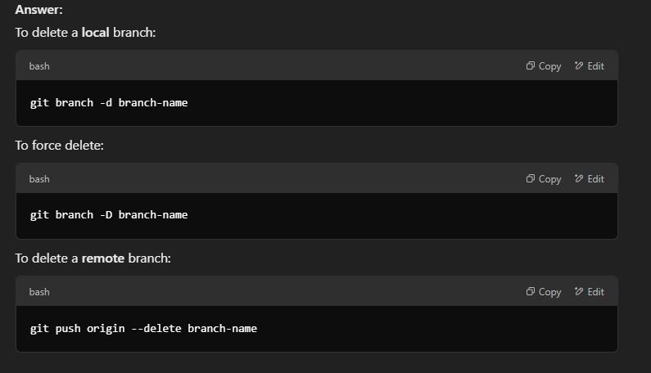

29. How do you undo the last commit in Git?
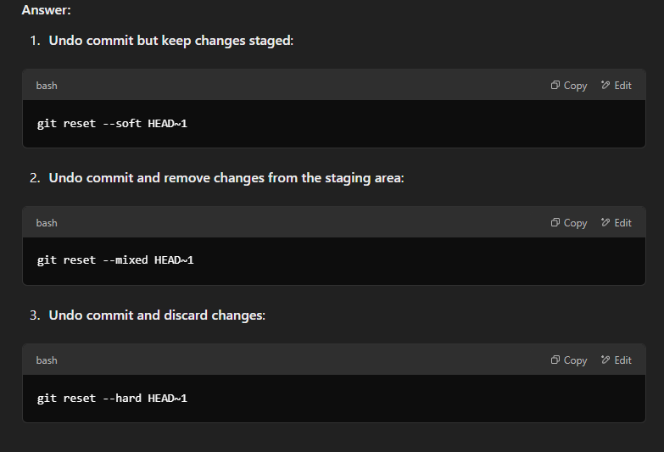

30. What does the .gitignore file do?
Answer:
The .gitignore file specifies which files and directories should be ignored by Git, preventing them from being tracked.
Example .gitignore file:
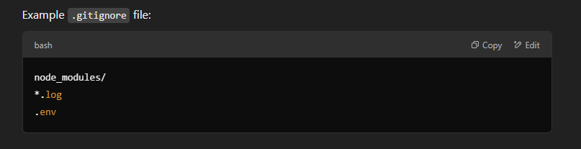

What is GitHub Actions? Have you used it?
GitHub Actions is a CI/CD (Continuous Integration/ Continuous Deployment) platform for automating the builds, test, and deployment process.
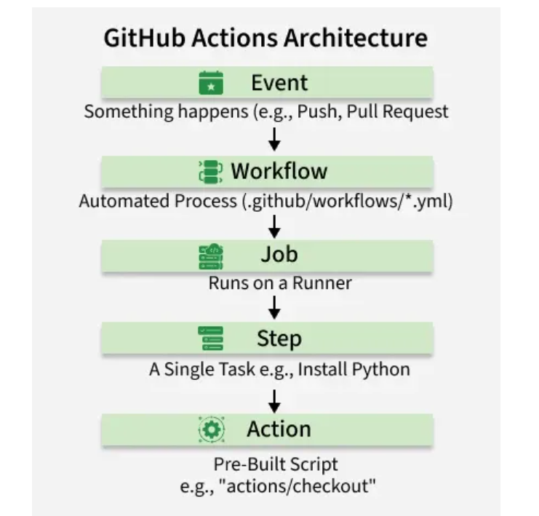
How It Works Components Of GitHub Actions
To understand GitHub Actions, you must understand its hierarchy. It follows a specific flow:
- Event: Something happens (e.g., a Push).
- Workflow: The automated process triggers.
- Job: A set of tasks running on a specific server (Runner).
- Step: A single task inside a job (e.g., "Install Python").
- Action: A pre-built script used within a step.

Difference between Git, GitHub, Bitbucket
The key difference is that Git is the open-source version control system itself, while GitHub and Bitbucket are web-based hosting platforms that manage and facilitate collaboration on Git repositories.
Parameter | Git | GitHub | Bitbucket
Type | Distributed Version Control System (DVCS) software | Web-based hosting service (SaaS platform) | Web-based hosting service (SaaS platform)
Function | Tracks changes in code locally, manages versions, allows branching and merging. | Provides a web interface and tools for hosting Git repos, fostering collaboration, and managing projects in the cloud. | Provides a web interface for hosting Git repos, with strong access controls and deep integration with the Atlassian suite of tools.
Owner | Open-source (maintained by the Linux Foundation) | Microsoft (since 2018) | Atlassian (since 2010)
Primary Focus | The underlying engine for version control. | Public, open-source projects, and a large developer community. | Private, proprietary codebases for professional and enterprise teams.
Integrations | Minimal external tool integration. | Large marketplace of third-party tools and GitHub Actions for CI/CD. | Seamless integration with Jira, Trello, and other Atlassian products.
How do you configure webhooks to trigger Jenkins from Git?
To configure webhooks to trigger Jenkins from a Git repository (like GitHub or GitLab), you need to set up both the Jenkins job and the Git repository's webhook settings.
In Jenkins
- Install the necessary plugin: Ensure the GitHub Integration Plugin (or a similar plugin for GitLab, e.g., GitLab Plugin) is installed via Manage Jenkins > Manage Plugins > Available plugins. A Jenkins restart may be required after installation.
- Create or configure a job:
  - Go to your Jenkins dashboard and create a new item (e.g., Freestyle project or Pipeline) or configure an existing one.
  - In the Source Code Management section, select Git and provide the Repository URL of your Git repository. If the repository is private, you will need to add credentials.
  - In the Build Triggers section, check the box for GitHub hook trigger for GITScm polling (or the relevant option for your Git host).
In Your Git Repository (e.g., GitHub)
- Navigate to Webhooks: Go to your repository's main page, click on Settings, and then select Webhooks > Add webhook.
- Configure the webhook details:
  - Payload URL: Enter the URL of your Jenkins server followed by /github-webhook/. For example: https://your-jenkins-url/github-webhook/.
    - Note: If Jenkins is running on a local machine, you may need to use a tool like WebhookRelay or ngrok to expose your local instance to the internet for the webhook to work.
  - Content type: Select application/json.
  - Secret (Optional but recommended): You can add a secret token here and configure the same token in your Jenkins job's configuration for added security.
  - Which events would you like to trigger this webhook?: For standard CI/CD, selecting Just the push event is sufficient. You can also select individual events like pull requests if needed.
  - Ensure the Active option is checked.
- Save the webhook: Click Add webhook (or Update webhook) to save the configuration. GitHub will usually send a "ping" request to verify the connection, which should show a green checkmark if successful.
Once configured, any push event to your Git repository will send a POST request to Jenkins, which will then trigger the associated build job.

